1. **Sign-up for Pigeon’s Nest.**

To sign up for Pigeon’s Nest please follow the following steps:

1. Visit our website URL <http://csmain/cs414/cs414_team2/index.aspx>

1. Click Sign-up button.
2. On the sign-up page enter your username, email address, password and confirm password.
3. Usernames cannot contain punctuation or spaces.
4. Emails must end with a pcci.edu domain.
5. A password is limited to between 8-128 characters and may not contain '|'.
6. Click Sign Up.

1. **Steps to verify your account**

After you’ve signed up for pigeon, you will receive Verification code in your pcci.edu email.

1. Enter verification code to confirm your email.

After you’ve verified your email, you will have an excess of our Nest.

1. **Steps to Sign In**
2. Visit our website URL <http://csmain/cs414/cs414_team2/index.aspx>
3. On the sign-up page enter your username password.
4. Click Sign In.

1. **Steps to retrieve Forgotten password**

After your sign-in failed sign in attempt to get excess to your nest follow the following steps.

1. Click Forgot password on your sign-up page.
2. On Forgot password page enter your Email address and username.
3. Click Send code.

You will receive a code in your pcci.edu email.

1. Enter a new password, re-enter new password and a code from the pcci.edu email.
2. Click Submit Changes.

**User settings**

The user settings page gives you access to change your password and lets you change your profile image. Also, don’t forget to keep track of your pigeon's points.

1. **Steps to update your password**
2. To update your password, enter your current password, new password, and confirm password.
3. Click Update.

1. **Steps to Update profile picture.**

1. Select any picture in the grid to update. You can review your selection when changes are made.

**Nests and Messaging**

Private and Group Messaging

From user registration, a new user will be greeted by a nest page. This will be the page where all private and group messaging will be located. In pigeon we call these messaging groups nests.

Private Nest

**Private Messaging** – Located under the “Contacts” tab, this will be where all messages between the users one on one will be located. To populate the contacts, tab the user will use the search bar located in the top middle of the nest page and enter the name of the user they wish to message. Note that this can only be done once if you want another private message between that user you will need to create a group messaging nest.

Users may search either partial usernames or the whole username to find the user they wish to message. Once the user hits enter on the search, a box will populate with all matching usernames. Simple select one user to open a private messaging nest between the users.

The private messaging will show the name of the user you are messaging in the contacts tab and in the top right above the usernames once the private messaging has been selected from the contacts tab.

Private nests have most of the functionality of a group nest, but users cannot be added to this type of messaging group, users cannot be kicked, and no local admin can be created in this group chat. If a user wishes to report a message, delete their own message or mute the conversation these features are available in this group type.

Group Nest

**Group Messaging** – Located under the “Nests” tab, this will be where all messages with one to many will be located. To populate the group nests a user can either accept a group invitation they have been sent or they may create a new nest of their own. To begin this process, click the “+ Create a Nest!” button under the nests tab.

After clicking create a nest the user will be able to enter a name for their nest and click the “+ Create Nest” button to finalize their nest creation and name selection. Note that user’s will only be able to create a total of five nests. Once they have reached this limit, they will need to delete one of their previous nests to create another. This limit does not apply to joining nests.

Group Nests: Roles and Controls

**Nest Creators** – This user will be highlighted in a blue box with the title “Nest Creator” inside of the right nest member list when inside of a group nest. These users will have access to a variety of controls to manage their nest. Including inviting users, promoting users to local admin, removing users, deleting the nest, muting the nest, and deleting user messages.

**Local Admins** – This user will be highlighted in a blue box with the title “Admin” inside of the right nest member list when inside of a group nest. Only nest creators and system admins can promote a user to local admin in a group nest. These users will have access to a variety of controls to manage a nest. Including inviting users, removing users, leaving the nest, muting the nest, and deleting user messages. Note this role is not a system admin, system admins are discussed later in the document under admin features.

**Default User Role** – These users will not be highlighted in the members list in a group nest. This role is assigned to any user when they are invited to a group. They are only able to delete their own messages, flag other user messages, mute the nest and leave a nest.

Nest creators are identified by this icon within a group nest.

 Local admins are identified by this icon within a group nest.

 System admins are identified by this icon within a group nest.

 Default users are identified by no icon within a group nest.

Nest Buttons and Controls

 Allows the creator, local admin, or system admin to invite a user to their group.

Allows the creator or system admin to promote a user to be a local admin. (see admin features for more information)

 Allows the creator, local admin or system admin to remove a user from their group.

 Allows the creator or system admin to delete the nest.

 Allows the local admin or a default user to leave the nest.

 Within nests both private and groups, any user type can mute the conversation.

 When the nest is muted, the user will not be notified of any new activity.

 Any user can also report any messages once this will give a message one flag and will be sent to the admin dashboard to be reviewed. Once a message is flagged twice or if it has been flagged by an admin the message will not appear in the group or private message.

When a message has been flagged by the logged in user the flag color will turn red for that user to show that they have reported it.

 When the message has been approved by a system admin the flag will replaced by a green check mark and will no longer be available for reporting. At this point the message has been deemed okay to remain on the site and will need to be deleted by and admin, the user that sent it, or a nest creator to be removed. If a system admin deems the message inappropriate that message will be removed from the private or group nest permanently.

 A nest creator and local admin can delete any user and local admin’s message, and any user can delete their own message.

Inviting Users

When the invite user button is selected the user will be brought to a search like the one for making a private message. Just like that search partial or full usernames can be used to search and all matching usernames will be displayed.

Clicking on a user in the list will send them an invitation to the group.

Sending Messages



Messages can be sent with only text or with a file attached. Note that to send a file the user must include text in the text box to send with the file.

 Messages with a file have this icon attached to them and the file will be displayed once the encryption text has been toggled off.

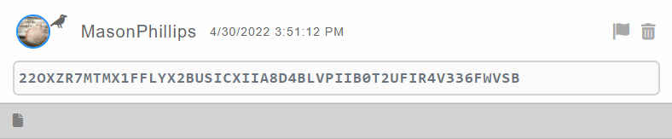

All messages will be obfuscated by cipher text to act as a shoulder surfing protection. Once the cypher text box has been clicked the text will be displayed along with any files attached to that message.

Notifications

When a user has a notification for either a nest invite, a message being reported or the outcome of a reported message. The bell icon at the top left of the nest icon will be colored red with an exclamation point.

 No new notifications

 New unread notifications

Clicking the notification bell will display all notifications and clear the red coloring from the bell.

In the notification page, users can see their group invitations and users can either accept or reject these invitations.

Below “Group Invitations”, is “Other Notifications” which details the users’ flagged messages either their own or somebody that the user reported.

When a user has activity in a private or group nest the “New” tab will appear in the top left of the nest page by the “Contacts” and “Nests” tabs. This tab can also be selected and will combine all new activity from both nests and contacts in the panel beneath the tabs.



**Administrative Features**

Admin Nest View

On the nest page there are two different admin types.

**Local Group Admins** – This admin type can be assigned to any user by either a nest creator or a system admin and will be highlighted blue with an admin tag inside of a nest. The local admins can use administrative features within a group which are kicking users, inviting users and deleting messages.

**System Admins** – This admin type has full access to the administrative suite within a nest which includes adding new users, removing users, locking nests, deleting nests, deleting messages, and promoting users to local admin. This admin does not appear in any nest as a user and is included in every nest that is created. System admins are also hidden in private messages as well, but these chats will not show up for system admins in their nests on the nest page.

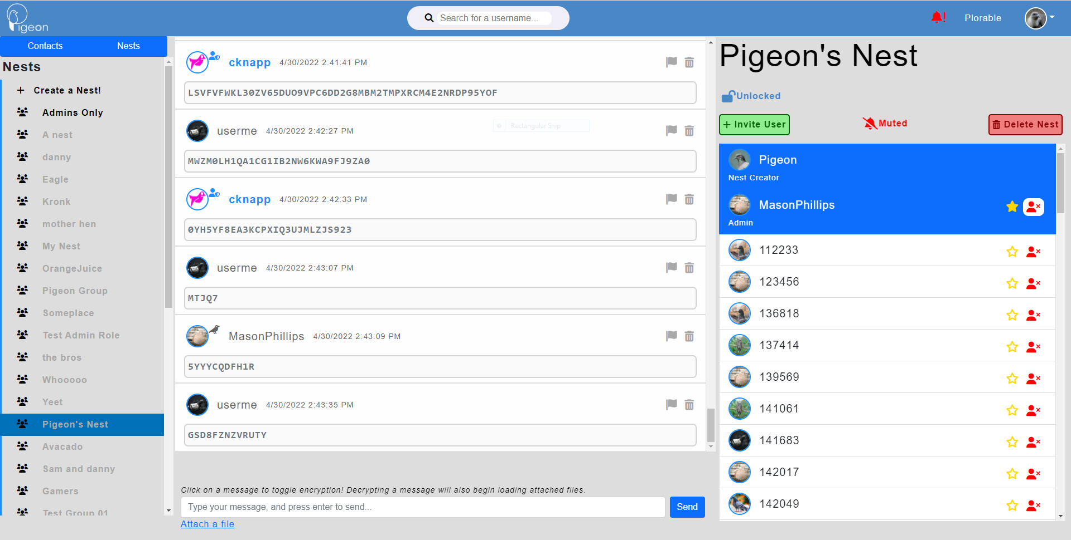

 Used to add users to a nest as an admin.

 Used to delete a nest as an admin.

 Used to unlock and lock nest as an admin.

 Used to delete messages in a group as an admin.

 Used to kick users from a group as an admin.

 Used to promote users in a group as an admin or nest creator.

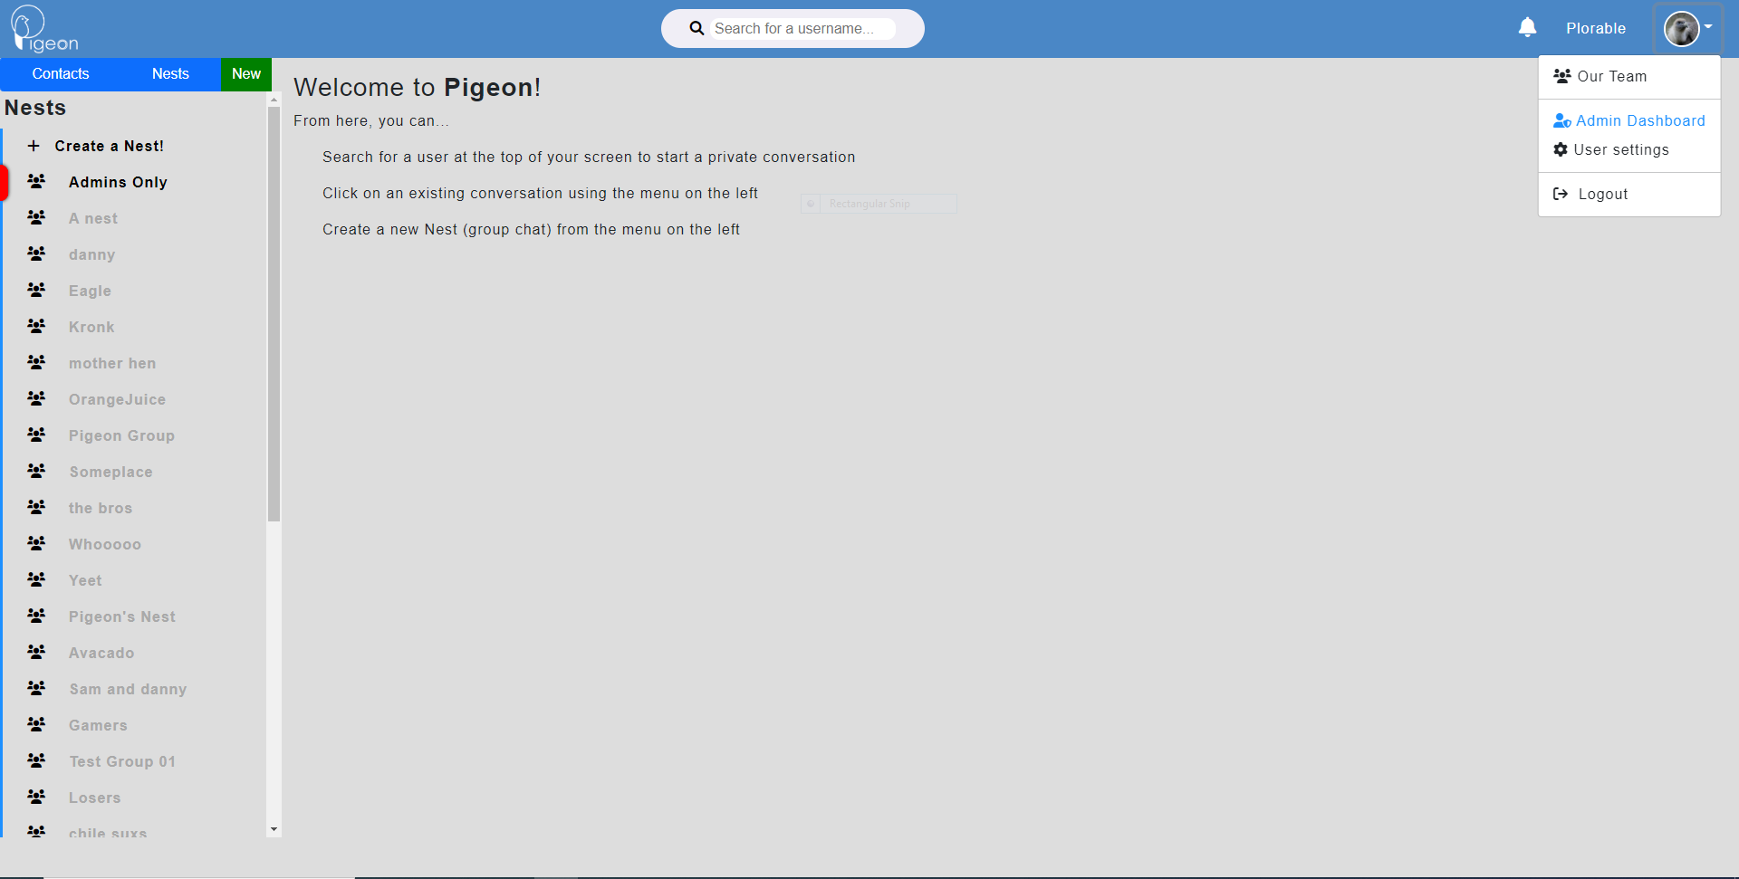

Administrative Page View

From the nest page access to the admin dashboard is available through the user account drop down in the top left of the page. Using the Admin Dashboard link button, you will be taken to the administrative page dashboard. The admin page view can be changed by using the banner at the top of the page.



**Admin Dashboard** – contains all users and all flagged messages pending review.

**Group Messaging Search** – allows admins to search for a specific group to view messages and members in that group.

**User Messaging Search** – allows admins to search for a user and view all messages they’ve sent and which groups they are a part of.

**Messaging Statistics** – allows admins to run statistics on different time periods to get message counts and activity.

**Nests** – Allows admins to quickly navigate back the main Nest page of the site.

Admin Dashboard View

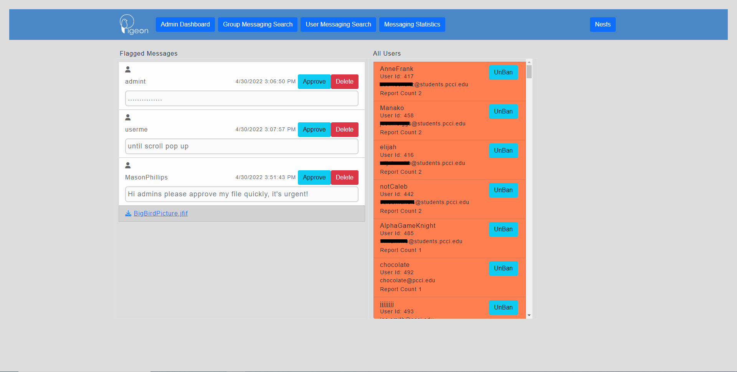

From admin dashboard system admins will be able to approve or delete user flagged messages. All user’s will also be viewable on this page where a system admin can look through users sorted by their report count and ban status to ban or unban them. This will also include basic information to use to further research the users accounts including usernames, id numbers and email addresses.

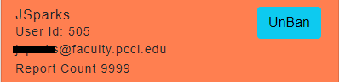

Users that have been banned are highlighted in a red orange box with a blue unban button.

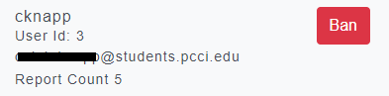

Users that have not been banned are not highlighted in their box and have a red ban button.

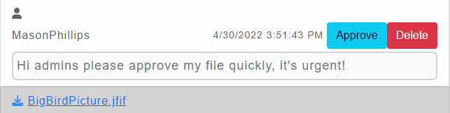

Flagged messages that come up in the flagged messages column will not be obfuscated for shoulder surfing protection and will include any download files as well as the message text. All messages sent by default user accounts with files attached will be flagged to be reviewed on the admin dashboard.

**Group Messaging Search View**

The group messaging search page view will allow admins to search for a group by id or by name to view the messages in that group and its users.

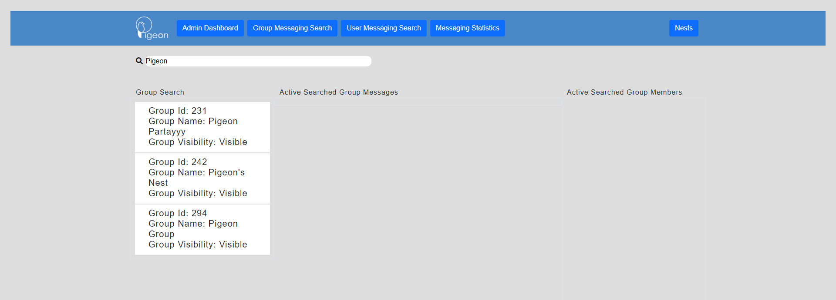

Once a name or id has been searched all matching groups ids will displayed in the “Group Search” column. This column displays the group name, id, and whether that group is deleted or visible. One of these groups can be selected and the “Active Searched Group Messages” will populate with the messages in the selected group and the “Active Searched Group Members” will populate with the members in the selected group with their user roles and id number.

Admins will also be able to delete messages in the Messages column and ban or unban users in the Members column. Note that messages without a delete button have already been deleted and will show up in this search despite not appearing on the nest view on the main nest page.

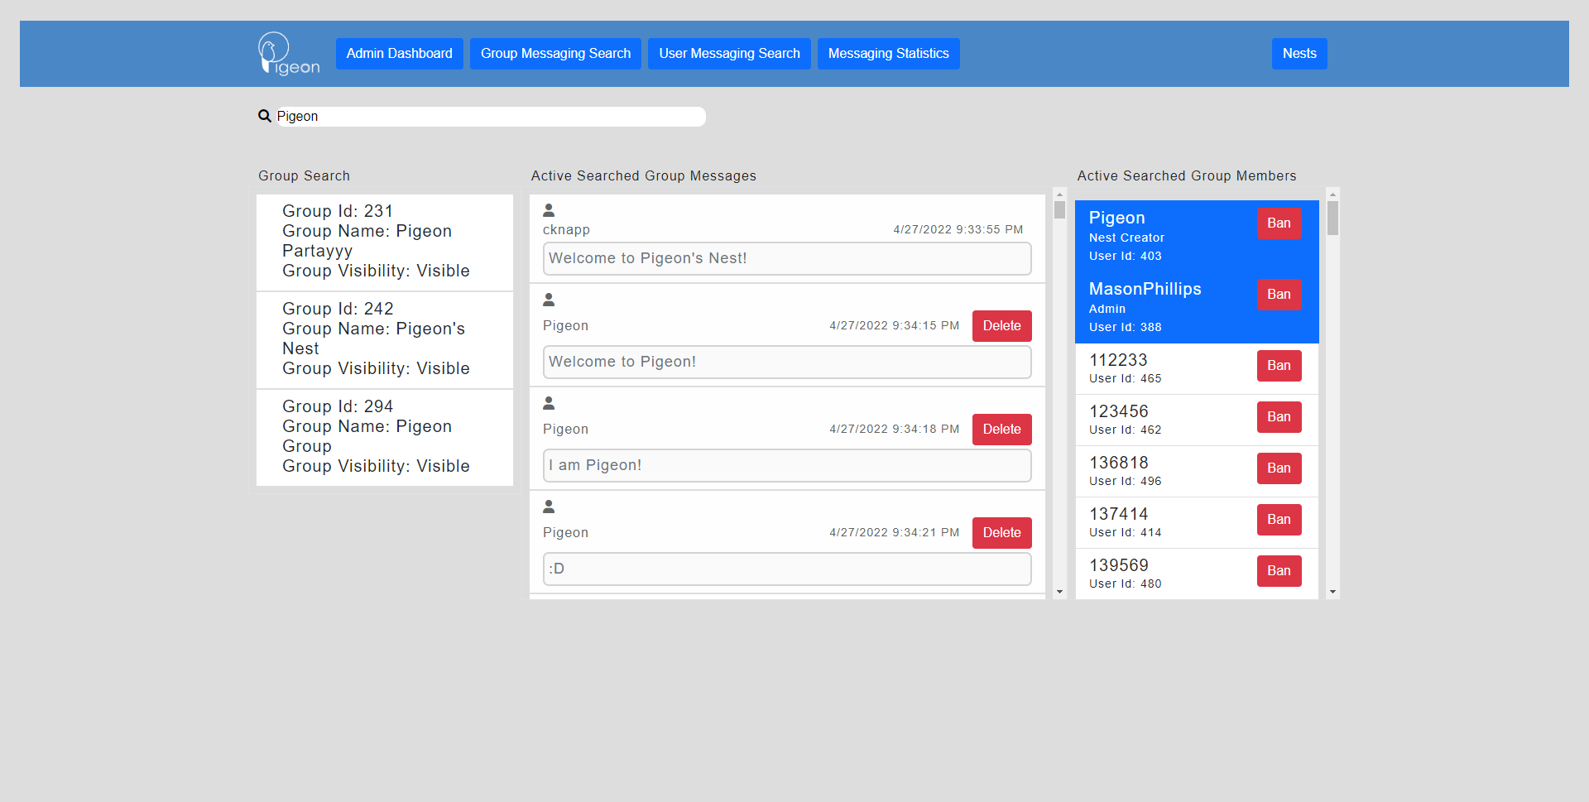

**User Messaging Search View**

The group messaging search page view will allow admins to search for a user by name. This allows admins to view all the messages they have sent and which groups they are members of.

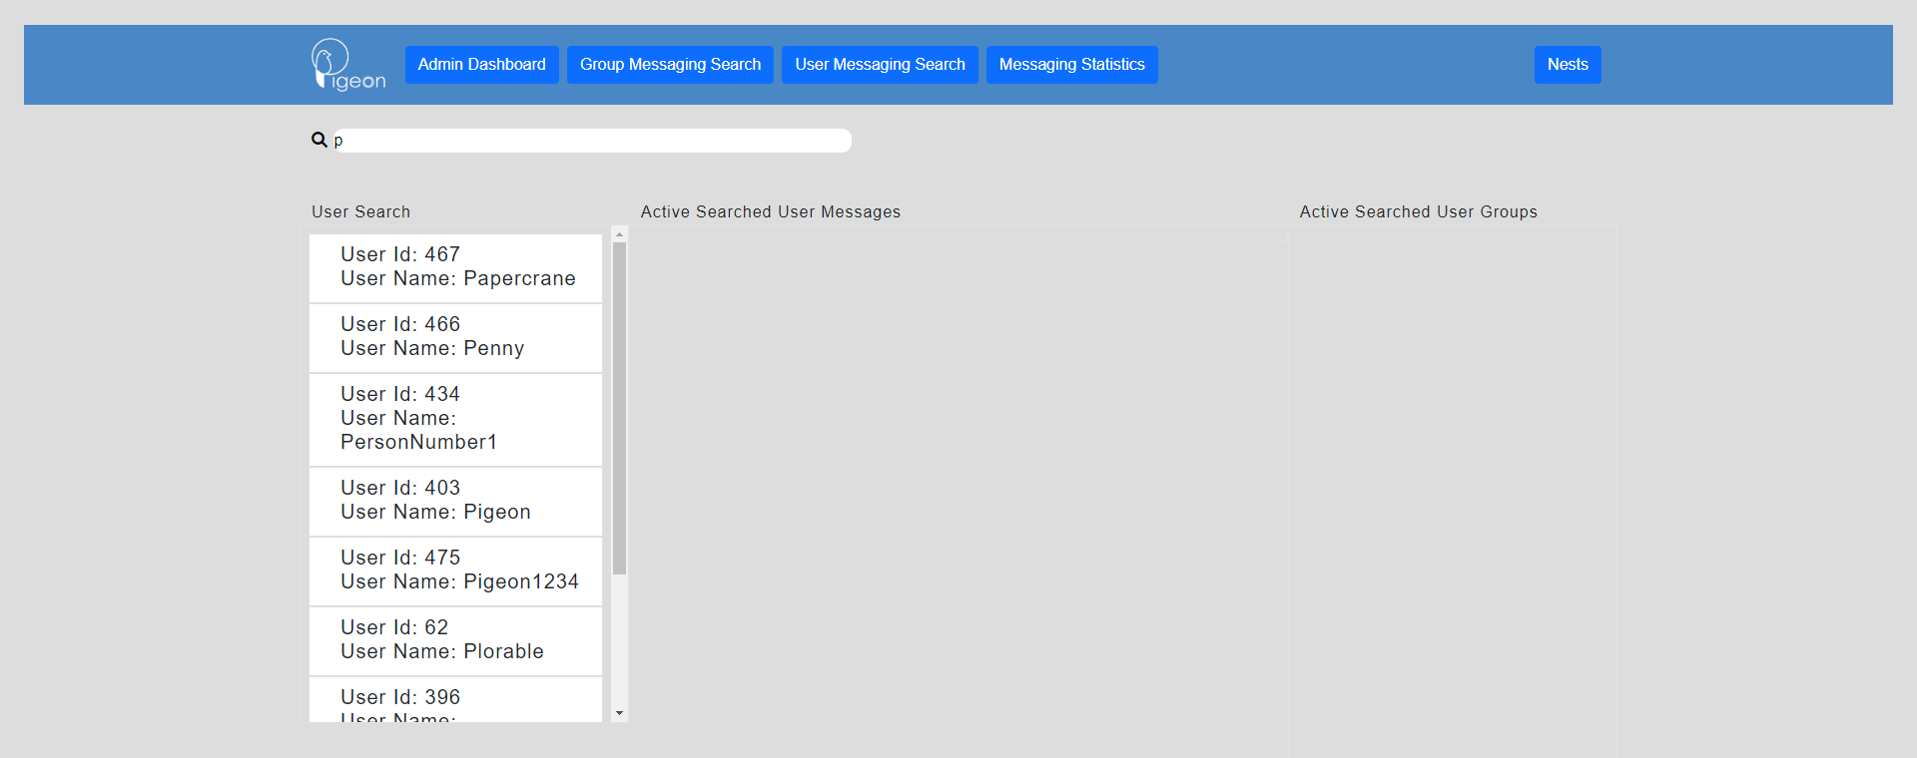

Once a name has been searched all matching usernames will be displayed in the “User Search” column. This column displays the usernames and ids. One of these users can be selected and the “Active Searched User Messages” will populate with the messages the selected user has sent since account creation and the “Active Searched User Groups” will populate with the user’s groups that they are a member of with their names and id number.

The message column will display the group name where the message was sent, the group id, and the date that the message was sent. Admins will also be able to delete messages in the Messages column. Note that messages without a delete button have already been deleted and will show up in this search despite not appearing on the nest view on the main nest page.

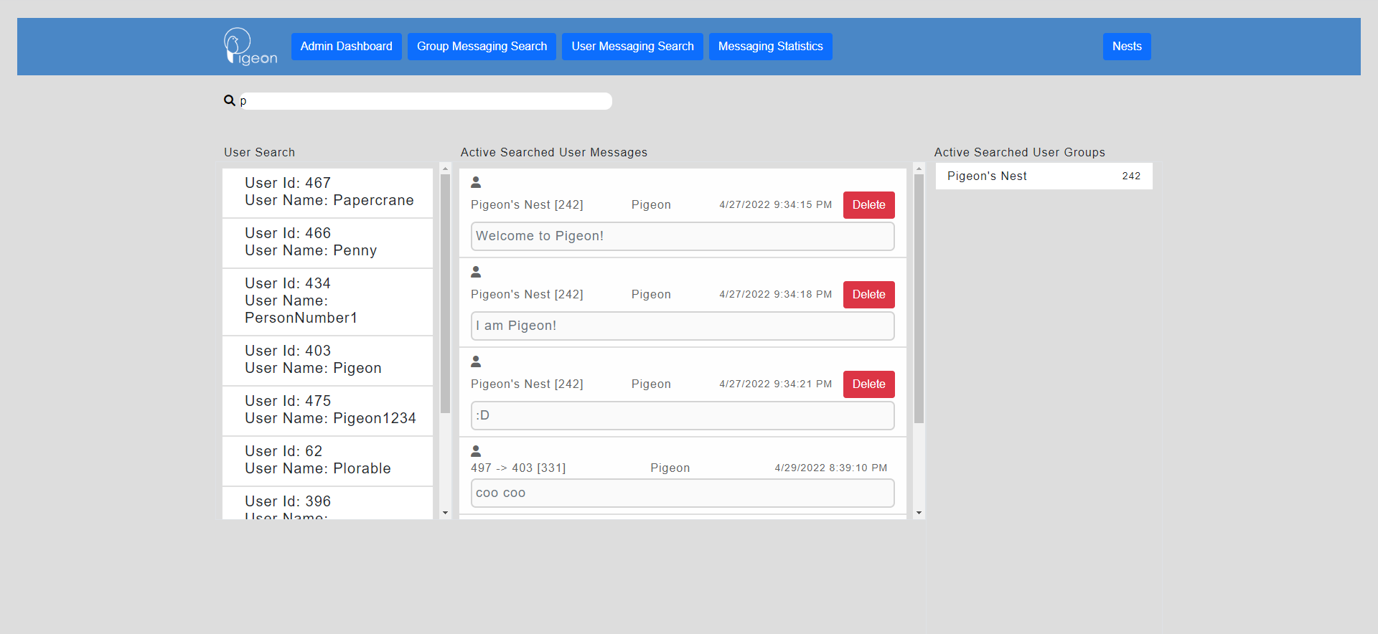

**Messaging Statistics View**

This statistical page of the admin page will allow admins to quickly view message counts in a time frame, most active user with message count in a time frame, most active group with message count in a time frame, message count in a time frame for a specific user, and message count for a specific group in a time frame. 